The Center for Enriched Living is grateful to corporate sponsors for their generous partnership and support of programs that dramatically improve the lives of people with intellectual and developmental disabilities. This year during Developmental Disabilities Awareness Month (March 1 – 31), please consider sharing the statement, below, with your employees to help bring awareness to the disability community, as well as the important role you play to create opportunities for inclusion and enrichment for this community.

Company Statement on Developmental Disabilities Awareness Month
This March, (Company Name) is proud to celebrate Developmental Disabilities Awareness Month to help champion equity initiatives that promote the full inclusion of people with disabilities in all facets of community life. We support local organizations like the Center for Enriched Living (CEL) that empower people with developmental disabilities by providing opportunities to learn, work, meet new friends, and achieve their dreams.
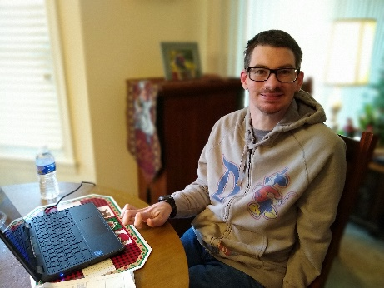
The pandemic left many people with disabilities in isolation, unable to attend their usual social programs where they enjoy vital connections to others. Thanks in part to support provided by corporate donations, members at CEL had access to technology they could bring home and at least enjoy virtual connections until it was safe to return to in-person programming.
Full inclusion in the community is a universal goal of Developmental Disabilities Awareness Month, but also one that (Company Name) strives to champion on a regular basis.
(Insert quote from employee on the importance of people with disabilities)
Since the passage of the Americans with Disabilities Act in 1990, the U.S. has made significant progress towards fully integrating individuals with developmental disabilities into general society. Individuals with disabilities who once were segregated into institutions are now being supported to live in the community. Nevertheless, people with developmental disabilities continue to experience social isolation, health challenges and unemployment at rates significantly higher than the general population. During the past two years, these trends have unfortunately, grown even more pronounced. Fortunately, there is hope:
Through programs like the ones offered at CEL, people with disabilities like Patricia (pictured) make their dreams of independent living come true. Not only did Patricia get the opportunity to find a job she loves, her employer realized what an exceptional, reliable employee she is and moved her into a larger role. She and her husband even met at CEL and celebrated their 10-year wedding anniversary last year.
Patricia says: “Without my job, I’d probably be in assisted living, when I’d rather be living on my own. I love getting a paycheck every month. I feel good being able to pay the bills, pay for groceries and our mortgage.”
You can see a short video about Patricia and her involvement in CEL’s Employment program – HERE.
(Company Name) encourages employees to volunteer or support organizations like CEL and remain committed to ensuring people with disabilities are valued and included in an accessible community.
Developmental disabilities are a group of conditions due to an impairment in physical, learning, language, or behavior areas. Examples include: ADHD, autism spectrum disorder, cerebral palsy, hearing loss, intellectual disability, learning disabilities, vision impairment, and other developmental delays. (Company Name) is proud to support organizations like the Center for Enriched Living that work to promote self-determination and inclusion for all people with developmental disabilities.
CEL relies on donations and volunteers to fulfill their mission. If you want to learn more about CEL’s programs, or find ways that you can get more involved, you can visit their website: www.CenterForEnrichedLiving.org/DDAM.
Throughout the month of March, you can also follow the hashtags #DDAwareness2022 and #DDAM to see how others are celebrating Developmental Disabilities Awareness Month.
